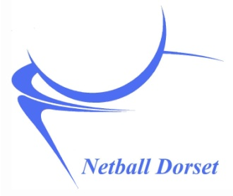
Pro Forma Invoice

Please send to Erica Phillips, Netball Dorset Finance Director, by email to netballdorsetfinance@gmail.com
Feel free to use your own invoices, as long as it contains all the details below.

Name:
Email:
Contact phone number:
EN Membership Number:

COACHING HOURS

Dates:

Head or Assistant coach

Number of hours at each session, and total at each coaching level

Venue:

Event (i.e. Which PDP, or detail other event)

MILEAGE

Dates:

Start postcode and destination:

Mileage for each session and total:

PAYMENT INFORMATION

Bank name:

Full name on account:

Sort code:

Account number:

I confirm that the income received from this claim is classed as self-employed earnings and I am liable for any tax due on this claim. Netball Dorset are not responsible for my tax contributions.
By submitting this form you are agreeing that all information provided is accurate and that Netball Dorset will retain the personal information on this form. You have a right to request a copy of the personal data that Netball Dorset holds about you at any time. If you wish to do so, please email netballdorsetfinance@gmail.com

By typing my name below, I agree that my electronic signature is the legal equivalent of my manual/handwritten signature on this document.

Signature: ____________________ Date: ____________________

